Version 6.0 Released January 2024

Table of Contents
ENTERING A NEW GRIEVANCE ACTION 2
GRIEVANCE EXAMPLE 7
SEARCHING FOR A GRIEVANCE 8
Adding grievance documents 8
MAKING CHANGES TO A GRIEVANCE IN PEOPLESOFT 11
ADDING STEPS 11
DELETIONS 13
FAQs 14
Are agencies required to use the grievance tracking functionality? 14
Who enters each step of a grievance? 14
When a step is completed, what should the overall status be? 14
What field does DPM use to track the date they received a Step 2 grievance? 14
When should I enter the grievance details into PeopleSoft? 14

Overview
The grievance tracking functionality was updated in STAR HCM in November 2016. DPM requires all agencies to use the functionality within PeopleSoft to track grievances within their agency.

SECURITY
Users must have the Grievance Security Role to access this functionality. Grievances are able to be viewed by all agency users with the Grievance Security Role, regardless of agency. The purpose of this is to allow an employee’s prior agency to input a grievance outcome for an employee who has transferred agencies prior to the grievance being fully resolved.

ENTERING A NEW GRIEVANCE ACTION
Role: Grievances

Use the following steps to enter a grievance action.

These steps list how to enter the grievance from receipt to step 1 resolution all at the same time. There may be times where you will only enter data through Step 4 – bullet point one and save, and then return at a later date to continue entering the remaining steps. See MAKING CHANGES TO A GRIEVANCE IN PEOPLESOFT for steps to update a grievance.

- STEP 1: Navigate to the WI Record Grievance Actions page.

- Navigation: Workforce Administrator Homepage > Human Resources tile > Person tile
- Click Grievance & Discipline dropdown and select Grievance
- On the Add a New Value tab
  - Note: The system will auto-generate the Grievance ID
- Click Add

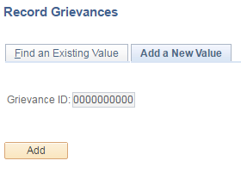

- STEP 2: Enter the grievance data

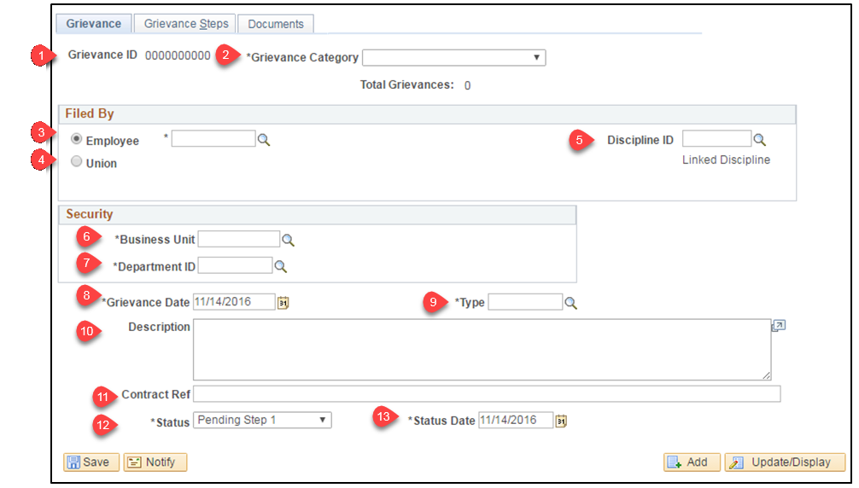

- Grievance ID: A unique identifying number for the grievance that will populate after saving the grievance
- Grievance Category (required): Select whether the grievance is related to an adverse employment decision, a condition of employment, or a contract violation (WLEA only)
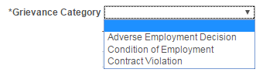
- Employee: Enter or select the employee ID of the employee who filed the grievance
- Union: Enter or select the union that filed the grievance (WLEA only)
- Discipline ID: If the grievance is related to a disciplinary action that is recorded in PeopleSoft, the grievance can be linked to it by clicking the magnifying glass

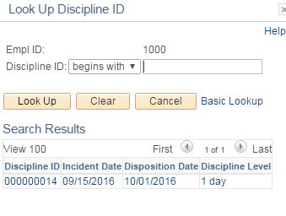
- Note: Once a Discipline ID is selected the words “Linked Discipline” become a hyperlink that will open a new window to the applicable disciplinary record

- Business Unit: Enter the business unit (agency number) the employee was in at the time the grievance was filed
  - Note: If a disciplinary action is linked to the grievance, the business unit will auto-populate from the disciplinary action in STAR
- Department ID: Enter the Department ID the employee was in at the time the grievance was filed
  - Note: If a disciplinary action is linked to the grievance, the department ID will auto-populate from the disciplinary action in STAR
- Grievance Date: Enter the date the grievance was received. If received via mail, use the date of postmark.
- Type: Enter the type of grievance. The magnifying glass can be used to search for the list of grievance types.
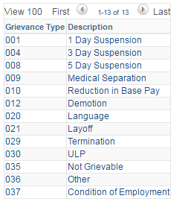

- Description: A description of the grievance may be entered in this text box
- Contract Ref: Enter the contract reference for this grievance, if applicable
- Status: As the grievance progresses, the status should be updated to reflect where the grievance is in the process

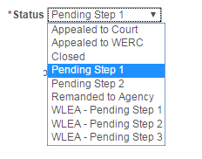

  - Note: The status history is not tracked. Each time the status is updated, it overrides the existing status.

- Status Date: Enter the effective date of the Status

- STEP 3: Click the Grievance Steps tab to add step 1

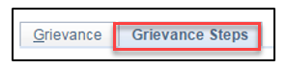

- STEP 4: Enter Step 1 data

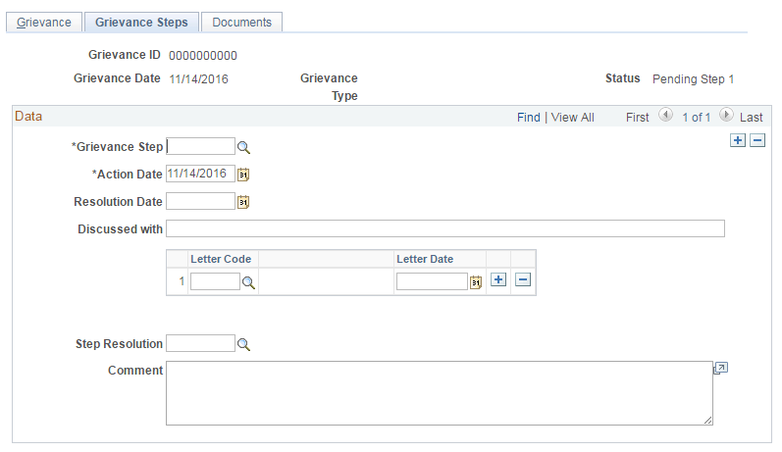
- Grievance Step: Select Step 1. Use the magnifying glass to search.

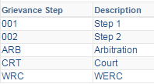

- Action Date: Date the grievance was heard
- Resolution Date: Date this step in the grievance was resolved
- Discussed with: Enter the name of the people present at the grievance meeting
- Letter Code: Select how the letter was sent. Use the magnifying glass to search.

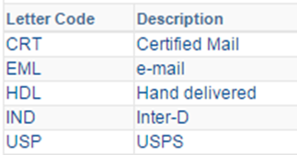

- Letter Date: Enter the date when the response was given to the employee. This should be the same date listed on the grievance form.
  - Note: If the letter was sent in more than one way, the + should be clicked to add an additional row
- Step Resolution: Enter the outcome of the step
  - Agencies should use the following steps for the Step 1 Resolution:
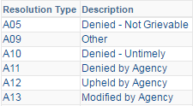
Note: Additional Resolution Types are available for selection, but those are to be used for Steps 2 and beyond.

- Comment: Additional information may be entered. This should be the same as the Employer’s Decision on the grievance form.

- STEP 5: Update the overall grievance status on the Grievance tab to “Closed” once a step resolution has been entered

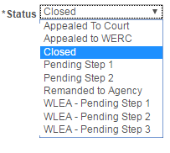

- STEP 6: Click Save

GRIEVANCE EXAMPLE
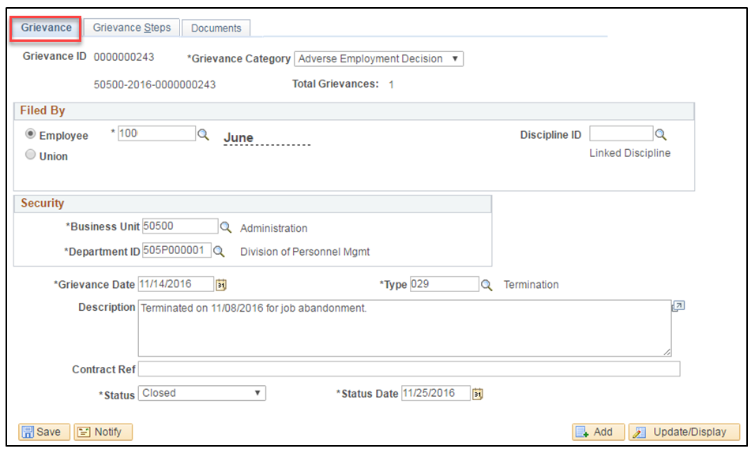

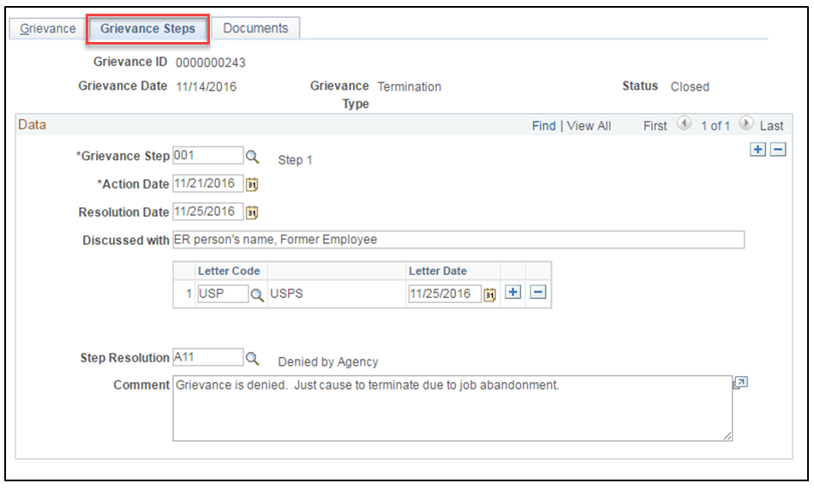

SEARCHING FOR A GRIEVANCE

- STEP 1: Navigate to the WI Record Grievances page

- Navigation: Workforce Administrator Homepage > Human Resources tile > Person tile
- Click Grievance & Discipline dropdown and select Grievance
- On the Find an Existing Value tab, enter the search criteria
- Click Search

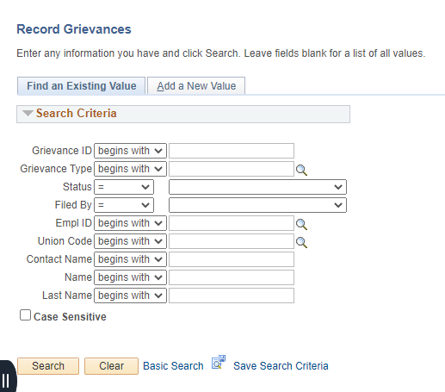
- STEP 2: Click on the record within the search results
Note: If only one grievance meets your search criteria, you will be taken directly to the grievance data

Adding grievance documents

- STEP 1: Navigate to the WI Record Grievance Actions page and search for the grievance using instructions above.

- STEP 2: Click the Documents tab and click Add Document Button

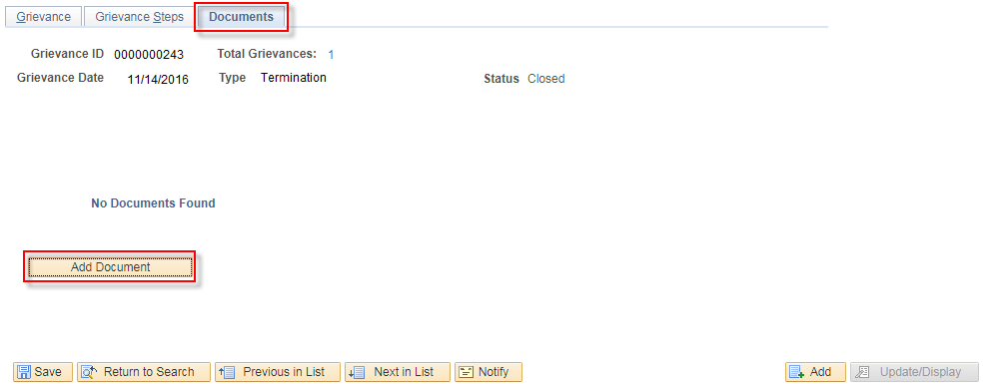

- STEP 3: Enter details about the document being uploaded
- Document effective date: The date the grievance was filed or response issued.
- Grievance Step: The step in the grievance process that this document is associated with. The user will only be able to select steps that have been added to the grievance.
- Comments: Enter any comments relating to the document that are needed.
- Click Upload Document

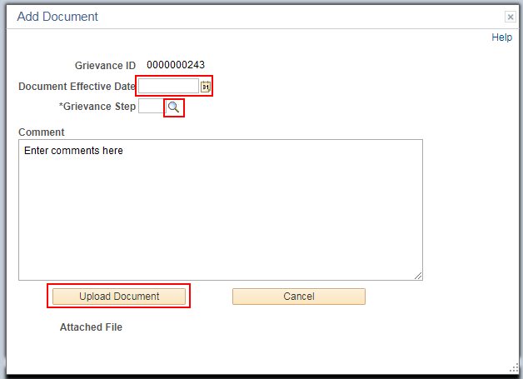

- STEP 4: Select the document to be uploaded.

All grievance documents should follow the below naming conventions

Document Type | Document Name
Step 1 Grievance Filed by Employee | Step1_LastNameFirstNameMI_mmddyy
Step 1 Grievance Response | Step1_RSP_LastNameFirstNameMI_mmddyy
Step 2 Grievance Filed by Employee | Step2_LastNameFirstNameMI_mmddyy
Step 2 Grievance Response | Step2_RSP_LastNameFirstNameMI_mmddyy
WLEA Step 1 Grievance Filed by Employee | WLEA1_LastNameFirstNameMI_mmddyy
WLEA Step 1 Grievance Response | WLEA1_RSP_LastNameFirstNameMI_mmddyy
WLEA Step 2 Grievance Filed by Employee | WLEA2_LastNameFirstNameMI_mmddyy
WLEA Step 2Grievance Response | WLEA2_RSP_LastNameFirstNameMI_mmddyy
WLEA Step 3 Grievance Filed by Employee | WLEA3_LastNameFirstNameMI_mmddyy
WLEA Step 3 Grievance Response | WLEA3_RSP_LastNameFirstNameMI_mmddyy
WERC Appeal by Employee | WERC_LastNameFirstNameMI_mmddyy
WERC Proposed Decision | WERC_PROP_LastNameFirstNameMI_mmddyy
WERC Final Decision | WERC_FINAL_LastNameFirstNameMI_mmddyy

- Click Choose File and select the document to upload

- Click Upload

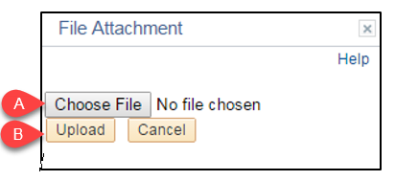

- Click Return

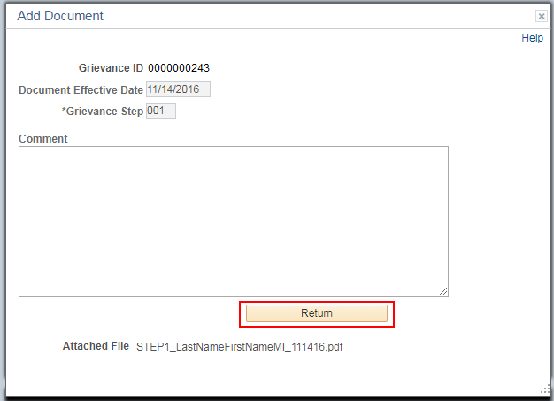

The document is now part of the grievance record:

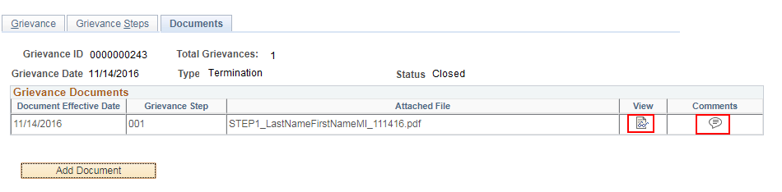

The document and the comments can be viewed directly from this page. Up to 12 documents may be added to a single Grievance ID. The documents will not be uploaded to an employee’s p-file
NOTE: If a grievance document needs to be deleted for any reason, a support ticket must be submitted to delete the record. Follow your agency’s procedure regarding submitting a STAR support ticket. It is important not to leave the erroneous document in PeopleSoft as it will be attached to an employee throughout their career.

MAKING CHANGES TO A GRIEVANCE IN PEOPLESOFT

ADDING STEPS

- STEP 1: Navigate to the WI Record Grievances page

- Navigation: Workforce Administrator Homepage > Human Resources tile > Person tile
- Click Grievance & Discipline dropdown and select Grievance
- On the Find an Existing Value tab, enter the search criteria
- Click Search

- STEP 2: Click on the record within the search results

- Note: If only one grievance meets your search criteria, you will be taken directly to the grievance data

- STEP 3: Update the overall Status and Status Date on the Grievance tab
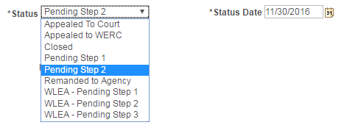

- STEP 4: Click the Grievance Steps tab to add an additional step to an existing grievance

- STEP 5: Click the plus (+) sign to add an additional step

- STEP 6: At a minimum, enter the Grievance Step. You may choose to save, and return later to enter the remaining information.

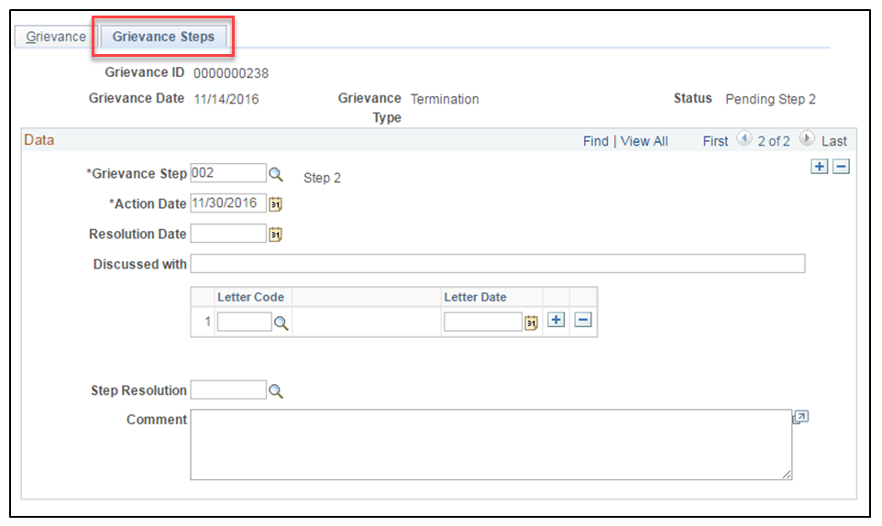
- STEP 7: Update the overall grievance Status and Status Date on the Grievance tab to “Closed” once a step resolution has been entered

- STEP 8: Click Save

DELETIONS

- STEP 1: Navigate to the WI Record Grievances page

- Navigation: Workforce Administrator Homepage > Human Resources tile > Person tile
- Click Grievance & Discipline dropdown and select Discipline
- On the Find an Existing Value tab, enter the search criteria
- Click Search

- STEP 2: Click on the record within the search results

- Note: If only one grievance meets your search criteria, you will be taken directly to the grievance data

- STEP 3: Navigate to the grievance row to be deleted by clicking the arrows at the top of the page

- STEP 3: Click the minus (-) button to delete the row

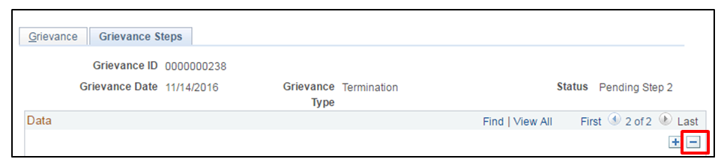

- STEP 4: Confirm the deletion

- Click OK

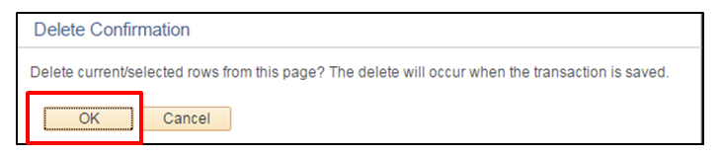

- Click Save

If there is only one grievance row in STAR for this grievance, it cannot be deleted by an agency. A JIRA ticket must be submitted to delete the record.

To submit a JIRA Ticket, you must be logged into the JIRA system:
https://all-star.wi.gov/servicedesk/customer/portal/1. You must be an approved user to log into the JIRA system, so please work with someone in your agency who is approved to log into the JIRA system if you are not an approved user.

Once you are logged into the JIRA system, you will be routed to a page that lists several ticket types from which to choose. Select the “Core Human Resources” option and proceed with submitting your ticket request.

Once submitted, your ticket request will be routed to the appropriate DPMC work unit for deletion.

*It is important not to leave the erroneous record in PeopleSoft as it will be attached to an employee throughout their career.

FAQs

Are agencies required to use the grievance tracking functionality?
- Yes, DPM requires agencies to use the grievance tracking functionality.

Who enters each step of a grievance?
- Agencies will enter non-represented step 1 grievances and WLEA represented step 1 and step 2 grievances.
- DPM will enter non-represented step 2 grievances and WLEA represented step 3 grievances.
- DOA Legal Services will enter WERC, settlement, circuit court, and WLEA represented Arbitration decisions.

When a step is completed, what should the overall status be?
- The overall status should be changed to “Closed”. If the grievant appeals to an additional step, either DPM (step 2) or the agency (WERC) will update the overall status to “Pending Step 2” or “Appealed to WERC”.
- Note: The grievance functionality does not store the history of the overall status, and only displays the most current status.

What field does DPM use to track the date they received a Step 2 grievance?
- DPM uses the Action Date on the Step 2 row.

When should I enter the grievance details into PeopleSoft?
- It is recommended that you enter information on the Grievances tab and add the Step 1 row at the time the grievance is received by the agency. Once Step 1 is resolved, you can go back in and update the overall status to closed and fill in the data for Step 1.
- When DPM receives Step 2 grievances, a record of the Step 1 grievance should be in PeopleSoft. If there isn’t a record in PeopleSoft, DPM will reach out to the agency to have them enter it.

Administrative Information
- This job aid was updated on 5/10/2023 to clarify the entry of WERC, settlement, circuit court, and WLEA represented Arbitration decisions in the grievance module.
- This job aid was updated in January 2024 to include detailed instructions regarding how to submit a JIRA ticket for a deletion request.

